**Assignment 1**

**DUE: Sunday, September 15, 2024**

**INSTRUCTIONS**: You have 3 choices for answering these questions. If you are able to alter pdf docs, then you may answer your questions right on this document. If not, you may either answer the questions on a separate sheet or print the assignment, answer by hand, and submit fully legible photos of your work.

Using the map on pages 432-433 entitled World Ocean: Sea Limits (or use slide 2 from Lecture 2) choose your favorite sea and answer the following questions:

1. What is the name of your favorite sea?

The Mediterranean Sea

1. Which body/bodies of water does your sea touch?

The Atlantic Ocean – through the Strait of Gibraltar

The Black Sea - through the Dardanelles

The Rea Sea - through the Suez Canal

1. Provide the approximate latitudinal and longitudinal boundaries of your favorite sea. (As an example, Part 4 of your book delineates the geographic boundaries of each ocean, with the Atlantic Ocean boundaries being Equator (0) to 60°N, 98°W to 2°W).

Mediterranean Sea: (30°N to 46°N, 6°W to 36°E)

1. In a few sentences, describe why you chose this sea and features of interest for you.

I choose the Mediterranean Sea due to its massive historical significance, its extreme biodiversity, and because it is one of the only seas I have personally visited. Its historical significance lies in the fact that over the course of human history, the Mediterranean Sea has hosted some of the greatest and most influential civilizations, such as the Greeks, Romans, Egyptians, and Alexander the Great. From my limited research, many sources indicate that the Mediterranean Sea is home to over 17,000 marine species, a feature I find fascinating. Finally, several years ago, I visited the Mediterranean Sea on vacation with my family, making it one of the very few seas that I have traveled to and touched. This combination of rich history, diverse marine life, and personal experience makes the Mediterranean Sea particularly special to me.

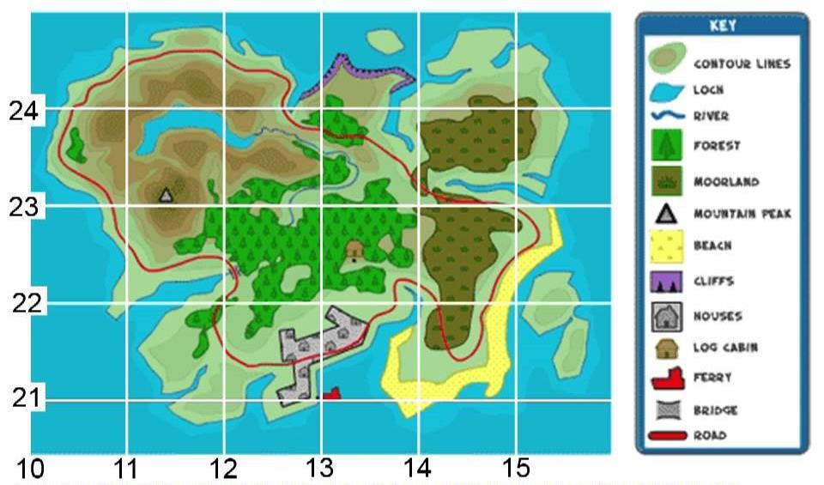

**Figure 1.** *Map of Somewhereland Island, right here on Earth.*

1. Using Figure 1, above, provide the most accurate reading you can for the latitude and longitude of the Log Cabin.

(22°50’N, 13°34’E)

1. At which latitude and longitude can the Mountain Peak be found?

(23°06’N, 11°48’E)

1. In Figure 1, what latitude and longitude is the starting point for the ferry?

(21°00’N, 13°00’E) (assuming a dock which the ferry uses)

1. Using the key to the map above, what type of terrain can be found at the following locations?

A). 23°75’N, 14°50’ - Moorland

B). 21°10’, 13°91’ - Beach

1. Provide the approximate geographic boundaries of the whole island (as you did for Question 3, above).

(21°67’N to 24°79’N, 10°15’E to 15°52’E)

1. Describe what happens at divergent, convergent and transform plate boundaries and provide TWO (2) real-world examples of each. Detail whether earthquakes, volcanoes or both can be found at each boundary type.

Divergent – Tectonic plates move away from each other

1. Mid Atlantic Ridge (Atlantic Ocean)
2. Galapagos Rise (Pacific Ocean)

Earthquakes: Yes, Volcanoes: Yes

Convergent –Tectonic plates move towards each other

1. Himalayas (Asia)
2. Rockey Mountains (Central United States)

Earthquakes: Yes, Volcanoes: No

Transform – Tectonic plates slide past each other

1. San Andres Fault (California, USA)
2. Queen Charlotte Fault (Vancouver Island, CA)

Earthquakes: Yes, Volcanoes: No

13. Of all the water on Earth, some 97% is saltwater. Describe Earth’s water cycle. Explain how freshwater is recycled, and why all the water hasn’t become saltwater over the millennia.

Water Cycle:

Evaporation/Transpiration - Water is heated into water vapor or water vapor is released from plants and rises into the atmosphere

Condensation – Water vapor rises and cools turning into clouds

Precipitation – Water falls back to earth (rain, snow, etc.)

Collection – Water Collects in bodies of water, use by plants or into the ground

Freshwater Recycling:

When water turns to water vapor it leaves behind salt and other impurities, this process is called desalination. During the next phases of the cycle the desalinated water is reinduced into plants, ground water and other fresh water sources, as well as back into the saltwater bodies.

Not All Saltwater:

The natural desalination and constant movement of the water cycle ensures the balance of fresh and salt water in the ecosystem. While there is significantly more salt water than fresh water, fresh water is formed and distributed constantly.